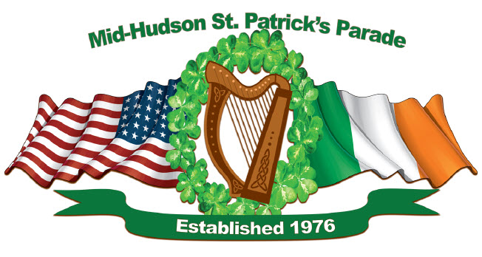
Band Line of March Response Form
Please return to:
mhsppc.line.of.march@gmail.com or
wkirnan@yahoo.com

Three Year Contract One Year Contract

Organization Name: ____________________________________________________________

Contact Person: ________________________________________________________________

Phone Number: ________________________________________________________________

Address: _____________________________________________________________________

Email Address: ________________________________________________________________

Approximate number of marchers: _______________________________________________

Instruments: __________________________________________________________________

Band fee (please include who to make the check payable to; checks cannot be made out to individuals):
_____________________________________________________________________________

Details of the assigned divisions and marching route will be posted the Friday before the parade on our Facebook page (https://www.facebook.com/midhudsonstpatricksparade) or our website (http://mhspp.org/).

Any questions or concerns, please contact the Line of March Committee at mhsppc.line.of.march@gmail.com.

Thank You!

