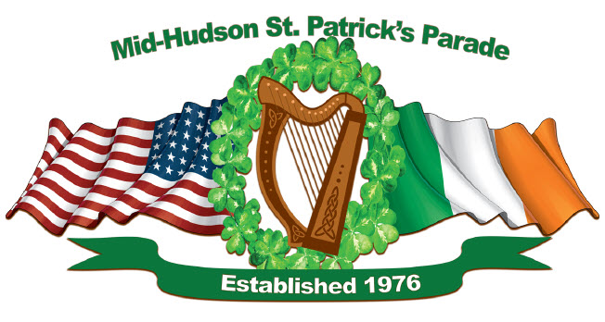

Mid-Hudson St. Patrick’s Parade
MARCHING UNITS
Registration Form

Please print in full, the name of your organization & address. A contact person, phone number and email address are also required. Please return it to the Parade Committee as soon as possible, but no later than February 28, 2023. The parade will be March 12, 2023, in Village of Goshen, NY.
ORGANIZATION/COMPANY/SCHOOL

______________________________________________________________

ADDRESS: _____________________________________________________

CONTACT PERSON: _____________________________________________

PHONE: (____) ___________ EMAIL: ________________________________

Signature: _____________________________________________________

Number of Marchers ______Number of Cars ______

Color Guard [ ] Yes [ ] No
Music [ ] Yes [ ] No
Banners / Flags [ ] Yes [ ] No
Special Requirements [ ] Yes [ ] No
(If yes, please explain) ______________________________________________
________________________________________________________________
________________________________________________________________
________________________________________________________________

Please return the form to either

wkirnan@yahoo.com

or

mhsppc.line.of.march@gmail.com

